HTML & CSS Exam Guideline

Uploading a file to the SoftUni system
You can upload a file to the SoftUni system by following the steps below:
- Archive the solved files in .zip/.rar/.7z format
- Press the "Choose file" button:

- If you have successfully uploaded the file, you will be able to see it in the SoftUni system, as well as the inscription "Done":
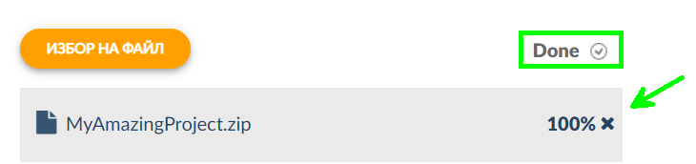

- If you decide to upload a new file, you can do so by following the same steps.
Note: Only the LAST uploaded file is saved.

